Statement of Design Selection and Rationale
Contents
- Introduction
- Design Selection and Rationale
  - Authentication and Authorisation
  - Web Application Templating Engine
  - Database Transactions
  - Trades
  - Reports
  - Stock Value Generator
- References

Introduction
This document describes the design in which the Real-Time Stock Trading Simulator will be implemented. Two technical designs were proposed (Technical Design I and Technical Design II) that deconstructed the overall project into separate sections. Furthermore, the Critical Design Assessment provided metrics on the technology stack and design approaches to provide a quantifiable way to compare the designs.
Given that the decoupling permitted in either technical design, it is possible in the majority of cases to select and choose sub-designs to meet the design goals for the project. The main aspects of Technical Design I have been chosen, e.g. service structure and database access. The rationale for choosing Technical Design I is given below where some elements of Technical Design II have been utilised given the analysis from the design assessment.

Design Selection and Rationale
Authentication and Authorisation
Spring Security will be used to implement authentication and authorisation within the project. The Critical Design Assessment compared two comparable classes of Spring Security and Shiro (the security framework of choice in Technical Design II) integral to framework usage. The intent was to measure how difficult it would be to maintain usage of the security framework.
Chidamber-Kemerer metrics showed a clear difference in this regard, where Shiro was significantly more complex in RFC and WMC. This can be interpreted as Shiro being more complex and more difficult to read.
The greater maintainability of Spring Security is additionally shown in the example implementations provided by the Critical Design Assessment, where the Spring Security example is shown again to have lower RFC and WMC (Table 6, Critical Design Assessment).
Spring Security performed poorly in a SonarQube analysis, showing more vulnerabilities than Shiro. However, this is considered a fair trade-off considering the ease of usage of Spring Security, performance (Table 5 of Critical Design Assessment), as well as the widespread usage of Spring Security. This helps enable us reach the project's design goals of maintainability and reliability.

Web Application Templating Engine
Somewhat linked to the choice of security framework, Thymeleaf of the first technical design will be used as the web application templating engine. This is because Spring Security, as well as other Spring projects with web front-end examples, provide tutorials specifically with the Thymeleaf engine. This is expected to provide maintainability and reliability given the amount of documentation.
The speed issues cited in the Critical Design Assessment are not considered an issue within the scope of the current project. Khan (2017) found Thymeleaf slower than FreeMarker testing with 25,000 requests at a concurrency level of 25. This project is not expected to receive a similar number of parallel requests.

Database Transactions
Spring Data is selected as the database transaction framework. Similar to the Chidamber-Kemerer metric comparison done for analysing Spring Security against Shiro, Spring Data showed to be less complex than Hibernate.
Technical Design I used Spring Data and the repository design pattern in comparison to Technical Design II which used a generic data access layer. The repository design pattern showed better maintainability (Table 8, Critical Design Assessment).

Trades
Technical Design I depends on Spring Data JPA repositories to decouple the data source from the project code. This causes the trading code to be more maintainable than the choice of Technical Design II, which moves the decoupling from the data access object to the service level, i.e. implementing the interface UserStockService with the concrete HibernateUserStockService. Technical Design I’s design is therefore chosen for the project.
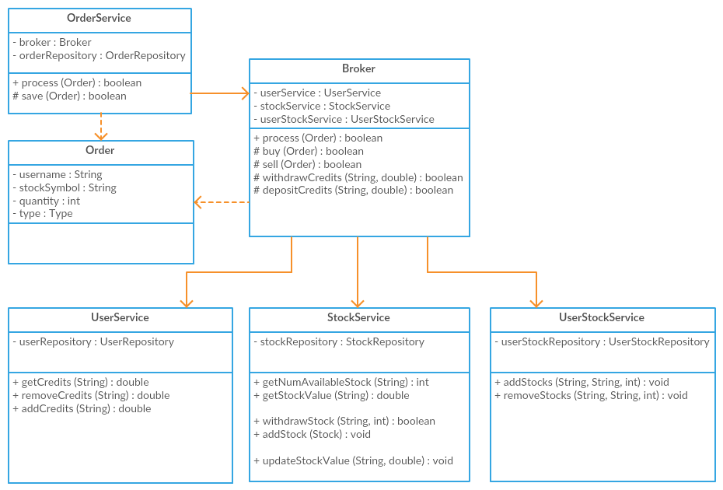
Figure 1, Broker class diagramme from Figure 6 of Technical Design I
However, Technical Design II has a benefit in that it puts the Broker in charge of all operations, from trade records to transactions. Given the project requirement’s emphasis on the broker as the omnipotent orchestrator, the OrderController will not be used as per the first design, but rather the BrokerController.

Reports
The design to accomplish report generation will be done as specified by Technical Design II. This provides benefits over Technical Design I by utilising services in a central ReportGenerator class. The ReportGenerator then populates reports accordingly to their definitions. In comparison, Technical Design I creates multiple report classes per report definition which all contain services as member variables. Choosing the design of Technical Design II allows us to most significantly avoid the object coupling of the other design.

Stock Value Generator
Technical Design II’s design for stock value generation is again simpler. It is more maintainable than that of Technical Design I and is thus chosen for the project, showing lower RFC and WMC. However, to stay consistent with the above chosen designs regarding service management and database access, the StockGenerationService should be a concrete class with repository instance variables.
References
Khan (2017) Templating Engines for Java WebApps [online], https://javaeworld.blogspot.co.uk/2017/02/template-engines-for-java-webapps-velocity-freemarker-thymeleaf-rythm.html (Accessed 20 June 2017)

